CONNECT POINT
Welcome to Harmony Baptist Church
573-693-2513
e-mail: info@hbcmo.org
www.hbcmo.org

Please fill out and put into the Offering Plate.

Name: _______________________________
Spouse: ______________________________
Address: _____________________________
____________________________________
City: ________________________________
State: ____________ Zip: _______________
Phone#
____________________________________
Email:
____________________________________
Preferred contact ______Text
______Email
______Phone

Children's Name/Ages:
1._________________________________
2._________________________________
3._________________________________
4._________________________________

How can we help you connect?
____ Add me to the mailing list
____ I’m in the area less than 6 months
____ I recently moved
____ I want to speak with the pastor
____ I’m interested in joining HBC

•Sunday School —@ 9:30am
Sundays @ Harmony
•Sunday Morning Worship—@ 10:45am.
Tuesdays @ Harmony
•Ladies Bible Study @ 10:00am
Tuesdays @ Harmony
•Family Mid-Week Recharge
Thursdays @ Harmony
Wednesdays @ Harmony
Wednesdays @ Harmony
•Men’s Bible Study, Thursday’s, @ 6:30pm, Location: Chris Cook’s home, 24720 Hwy 17, Waynesville.
Tuesdays @ Harmony
•Ladies Bible Study, Thursday’s, @ 6:15pm, Wendy’s Home, 100 Mary Catherine,
Waynesville
Upcoming Events @ Harmony
•Women’s Event, Friday, Jan 23^{rd,} 6:30 pm

Harmony Staff
Pastor
Jeremy Courtois jcourtois@hbcmo.org
Administrative Assistant
Jan Sosebee jsosebee@hbcmo.org
Director of Family Ministries
Gina Coffelt gcoffelt@hbcmo.org
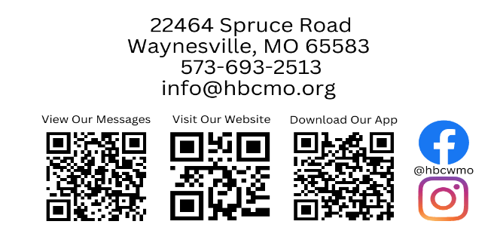





Our Mission
Our mission is to develop authentic believers who strive to connect people to Jesus, teach them to engage in discipleship, and multiply the Kingdom in the process.

Matthew 28:19-20
“Go, therefore, and make disciples of all nations, baptizing them in the name of the Father and the Son and of the Holy Spirit, teaching them to observe everything I have commanded you. And remember, I am with you always, to the end of the age.”

The Savior of the World
MAIN POINT: Jesus brings people from hearing about Him to knowing Him as the Savior of the world.
John 4:39–42
Three ways Faith Moves
1. Faith Sparked by a
, v. 39.
2. Faith Strengthened by the
, vv. 40–41.
3. Faith Confessing
, v. 42.
Questions for the Week
1. How will I intentionally hear from Jesus through His Word this week?
2. Who is one person I can invite to “come and see” what Christ has done in my life?
3. Where might familiarity with Jesus be replacing obedience to Him?
4. How does believing Jesus is the Savior of the world change how I view the people around me?
5. What fear or distraction do I need to surrender in order to obey Christ this week?
My Next Step

□ Today I made a decision to accept
Jesus Christ.
□ I want to rededicate my life to Christ.
□ I want to be Baptized.
□ I want to join a small group.
□ I want more information about HBC.
□ I am interested in serving at HBC.
□ I would like to talk to someone about
_________________________________
_________________________________
If you check one of the boxes above, a
staff member will follow up with you.

Prayer Request:
How can we pray for you?
_________________________________
_________________________________
_________________________________
_________________________________
_________________________________
_________________________________
_________________________________

